USE CASE DOCUMENT

Shree Mart
Online Grocery Shopping Platform

Version: 1.0

Prepared By
Ganesh Mahajan
MBA – Finance & ITM

Prepared Date
04 July 2026

Confidential

Introduction

This document describes the interaction between users and the Shree Mart Online Grocery Shopping Platform. It defines how customers and administrators interact with the system to perform various business operations.

USE CASE DIAGRAM

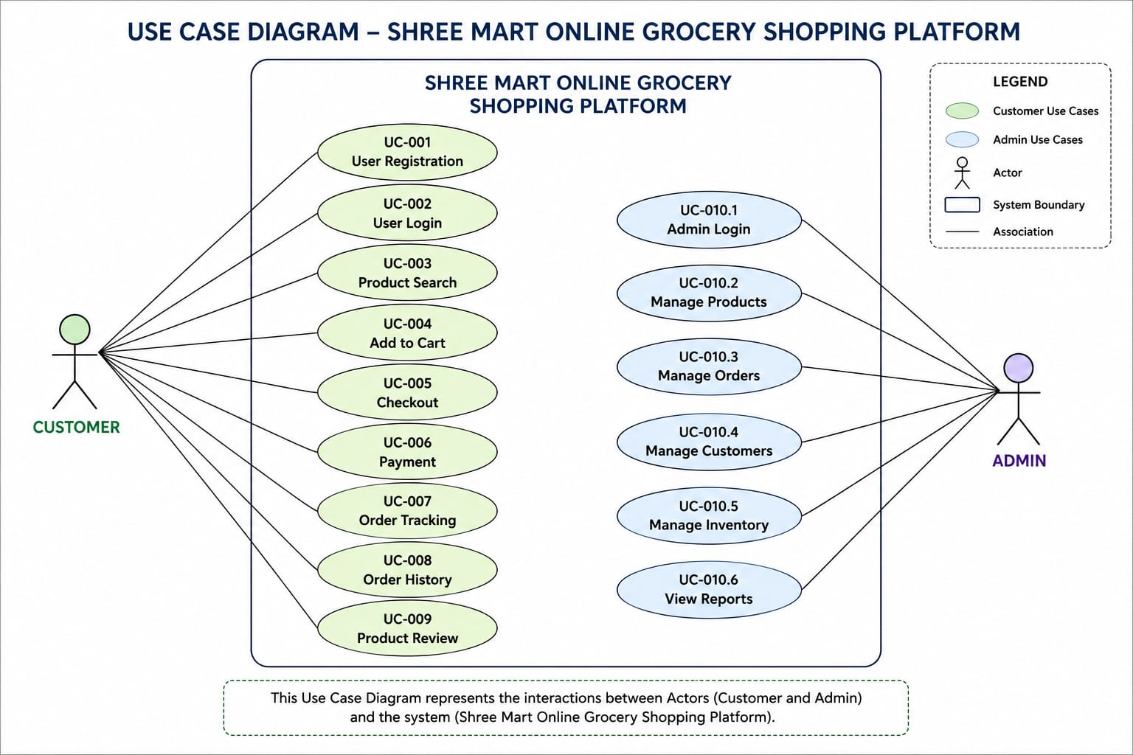

UC – 001 – User Registration
Field | Description
Use Case ID | UC-001
Use Case Name | User Registration
Primary Actor | Customer
Goal | Register a new account
Preconditions | Customer is not registered
Postconditions | Customer account is created successfully
Main Flow
- Customer opens the registration page.
- Customer enters personal details.
- Customer submits the registration form.
- System validates the information.
- System creates the customer account.
- Registration success message is displayed

Alternate Flow
- If the email or mobile number already exists, the system displays an appropriate error message

Exception Flow
- If mandatory fields are empty, the system prompts the customer to complete the required information

Uc – 002 - User Login
Field | Description
Use Case ID | UC-002
Use Case Name | User login
Primary Actor | Customer
Goal | Access the customer account
Preconditions | Customer is already registered
Postconditions | Customer is logged into the system

Main Flow
- Customer opens the login page.
- Customer enters email/mobile number and password.
- Customer clicks the Login button.
- System validates the credentials.
- System grants access to the customer dashboard.

Alternate Flow
- If the password is incorrect, the system displays an "Invalid Credentials" message.

Exception Flow
- If mandatory fields are empty, the system prompts the customer to complete the required fields.
UC – 003 – Product Search
Field | Description
Use Case ID | UC-003
Use Case Name | Product Search
Primary Actor | Customer
Goal | Search for required products
Preconditions | Products are available in the system
Postconditions | Relevant products are displayed

Main Flow
- Customer enters a product name in the search bar.
- Customer clicks the Search button.
- System searches the product database.
- Matching products are displayed.

Alternate Flow
- If no matching products are found, the system displays "No Products Found."

Exception Flow
- If the search field is empty, the system asks the customer to enter a keyword.
UC – 004 – Add to Cart
Field | Description
Use Case ID | UC-004
Use Case Name | Add to cart
Primary Actor | Customer
Goal | Add selected products to the shopping cart
Preconditions | Customers is logged in and products are available
Postconditions | Selected products is added to the shopping cart
Main Flow
- Customer browses or searches for a product.
- Customer selects the product.
- Customer clicks the Add to Cart button.
- System adds the product to the shopping cart.
- System displays a confirmation message.

Alternate Flow
- Customer changes the quantity before adding the product to the cart.

Exception Flow
- If the product is out of stock, the system displays "Product Out of Stock."

UC – 005 – Checkout
Field | Description
Use Case ID | UC-005
Use Case Name | checkout
Primary Actor | Customer
Goal | Place an order successfully
Preconditions | Shopping cart contains at least one product
Postconditions | Order is placed successfully

Main Flow
- Customer reviews the shopping cart.
- Customer clicks Proceed to Checkout.
- Customer selects the delivery address.
- Customer chooses a payment method.
- Customer confirms the order.
- System generates the order confirmation.

Alternate Flow
- Customer changes the delivery address before confirming the order.

Exception Flow
- if payment fails, the system displays a payment failure message and asks the customer to try again.

Uc – 006 – Payment
Field | Description
Use Case ID | UC-006
Use Case Name | Payment
Primary Actor | Customer
Goal | Complete the payment securely
Preconditions | Customer has a confirmed the order and selected a payment method
Postconditions | Payment is successful and the order is confirmed

Main Flow
- Customer selects a payment method.
- Customer enters payment details.
- System verifies the payment information.
- Payment is processed successfully.
- System displays a payment success message.

Alternate Flow
- Customer selects a different payment method before confirming the payment.

Exception Flow
- Payment fails due to insufficient balance, network issue, or invalid payment details.
UC – 007 – Order Tracking
Field | Description
Use Case ID | UC-007
Use Case Name | Oreder tracking
Primary Actor | Customer
Goal | Track the current status of an order
Preconditions | Customer has placed an order
Postconditions | Current order status is displayed

Main Flow
- Customer logs in.
- Customer opens My Orders.
- Customer selects an order.
- System displays the current order status

Alternate Flow.
- Customer refreshes the tracking page to get the latest status.

Exception Flow
- Tracking information is temporarily unavailable.

UC – 008 – Order History
Field | Description
Use Case ID | UC-008
Use Case Name | Oreder history
Primary Actor | Customer
Goal | View previously placed orders
Preconditions | Customer is logged in
Postconditions | Previous orders are displayed

Main Flow
- Customer opens My Orders.
- System retrieves previous orders.
- System displays the order history

Alternate Flow
- Customer filters orders by date or status.

Exception Flow
- No previous orders are available.

UC – 009 – Product Review
Field | Description
Use Case ID | UC-009
Use Case Name | Product review
Primary Actor | Customer
Goal | Submit a product review and rating
Preconditions | Customer has purchased the product
Postconditions | Review and rating are successfully submitted

Main Flow
- Customer opens the purchased product.
- Customer enters a rating and review.
- Customer clicks Submit.
- System saves the review.
- Review is displayed successfully.

Alternate Flow
- Customer edits the review before submitting it.

Exception Flow
- Review submission fails due to a system error.

UC – 010 – Admin Dashboard
Field | Description
Use Case ID | UC-010
Use Case Name | Admin dashboard
Primary Actor | Admin
Goal | Manage the online grocery platform
Preconditions | Admin is logged in
Postconditions | Administrative tasks are completed successfully

Main Flow
- Admin logs in.
- Admin opens the dashboard.
- Admin manages products, customers, orders, and inventory.
- System saves the updates.
- Dashboard displays the updated information.

Alternate Flow
- Admin cancels an update before saving changes.

Exception Flow
- System fails to save changes due to a server error

